# Project 3

## Code:

import cx_Oracle  
import pprint  
import datetime  
  
con = cx_Oracle.connect("ARPIT/arpit123@localhost/xe")  
cur = con.cursor()  
  
def __max_likes__():  
 # maximum likes  
 cur.execute("select PictureID, count(likedby) from Likes group by (PictureID)")  
 op = cur.fetchall()  
 max = 0  
 id = 0  
 for o in op:  
 if (o[1] > max):  
 max = o[1]  
 id = o[0]  
 else:  
 continue  
  
 print("Maximum likes are to picture: ", id, " No. of maximum likes is: ", max)  
  
def __min_likes__():   
 # minimum likes  
 cur.execute("select PictureID, count(likedby) from Likes group by (PictureID)")  
 op = cur.fetchall()  
 min = 999  
 id = 0  
 for o in op:  
 if (o[1] < min):  
 min = o[1]  
 id = o[0]  
 else:  
 continue  
  
 print("Minimum likes are to picture: ", id, " No. of minimum likes is: ", min)  
  
  
def __who_liked_most__():  
 # who liked most  
 cur.execute("select likedby, count(pictureid) from Likes group by (likedby)")  
 op = cur.fetchall()  
  
 max = 0  
 id = 0  
 for i in op:  
 if (i[1] > max):  
 max = i[1]  
 id = i[0]  
 else:  
 continue  
 print("Maximum likes are by user: ", id, " No. of maximum likes is: ", max)  
  
  
def __music_pictures__():  
 # music pictures  
 cur.execute("select pictureID from pics where music=1")  
 op = cur.fetchall()  
 print("The pictures with music tags are with picture ID: ")  
 for i in op:  
 print(i[0])  
  
  
def __most_popular_tag__():  
 # most popular tag  
 cur.execute(  
 """select sum(arts)"Arts",sum(science) "Science",sum(music)"Music",sum(history)"History",sum(engineering)"Engineering" from Pics""")  
 op = cur.fetchall()  
 sumop = {}  
 i = 0  
 for x in cur.description:  
 sumop.update({x[0]: op[0][i]})  
 i += 1  
  
 maxval = 0  
 maxkey = ""  
 for key, value in sumop.items():  
 if value > maxval:  
 maxval = value  
 maxkey = key  
  
 print("Most popular tag is ", maxkey, " with ", maxval, " likes")  
  
  
def __oldie__():  
 # tag pictures older than 1 year  
 old = cur.execute("select pictureid from pics where extract(year from dateofpost)<2017 order by dateofpost").fetchall()  
 print("Old post")  
 for oldie in old:  
 print(oldie[0])  
  
  
  
def __most_liked_user__():  
 # most liked user  
 raw_likes = cur.execute(  
 """select count(likedby) as "max likes", pictureid from Likes group by (pictureid)""").fetchall()  
 likes_list = []  
 for raw in raw_likes:  
 likes_dict = {}  
 likes_dict["picid"] = raw[1]  
 likes_dict["likedby"] = raw[0]  
 likes_dict["userid"] = int(raw[1] / 100)  
 likes_list.append(likes_dict.copy())  
 # pp=pprint.PrettyPrinter(indent=4)  
 # pp.pprint(likes_list)  
  
 max_likes = 0  
 max_liked_user = 0  
 for i in range(1, 6):  
 likes = 0  
 for row in likes_list:  
 if row['userid'] == i:  
 likes += row['likedby']  
 print("Total likes for", i, "is", likes)  
 if likes > max_likes:  
 max_likes = likes  
 max_liked_user = i  
  
 print("Max liked user is", max_liked_user, "with", max_likes, "likes")  
  
  
  
def __delete_inactive_users__():  
 # delete inactive users  
 raw_raw_inactive = cur.execute("""select userid,dateofpost from Pics order by userid asc, dateofpost desc""").fetchall()  
 raw_inactive = []  
 for i in range(1, 6):  
 for raw_raw in raw_raw_inactive:  
 if raw_raw[0] == i:  
 raw_inactive.append((raw_raw[0], raw_raw[1]))  
 break  
  
 # print("Raw Inactive",raw_inactive)  
 date = datetime.datetime.today()  
 i = 1  
 for raw in raw_inactive:  
 if raw[0] != i:  
 print("User", i, "is inactive")  
 i += 1  
 else:  
 difference = date - raw[1]  
 # print(difference)  
 if difference.days > 365:  
 print("User", raw[0], "is inactive for ", difference.days, "days")  
 i += 1  
  
choice=1  
while(choice in range(1,9)):  
 choice=int(input("""  
 1.Max Likes  
 2.Min Likes  
 3.Who liked most  
 4.Music pictures  
 5.Popular Tag  
 6.Most liked User  
 7.Old Tagging  
 8.Delete Inactive Users   
 9.Exit\n"""))  
  
 if choice==1:  
 __max_likes__()  
 elif choice==2:  
 __min_likes__()  
 elif choice==3:  
 __who_liked_most__()  
 elif choice==4:  
 __music_pictures__()  
 elif choice==5:  
 __most_popular_tag__()  
 elif choice==6:  
 __most_liked_user__()  
 elif choice==7:  
 __oldie__()  
 elif choice==8:  
 __delete_inactive_users__()  
 elif choice==9:  
 print("Bye")  
 else:  
 print("Exit")

## Output:

C:\ProgramData\Anaconda3\python.exe "C:/Users/Arpit/Desktop/campus_connect/Module 3/instadb.py"

1.Max Likes

2.Min Likes

3.Who liked most

4.Music pictures

5.Popular Tag

6.Most liked User

7.Old Tagging

8.Delete Inactive Users

9.Exit

2

Minimum likes are to picture: 302 No. of minimum likes is: 1

1.Max Likes

2.Min Likes

3.Who liked most

4.Music pictures

5.Popular Tag

6.Most liked User

7.Old Tagging

8.Delete Inactive Users

9.Exit

3

Maximum likes are by user: 5 No. of maximum likes is: 8

1.Max Likes

2.Min Likes

3.Who liked most

4.Music pictures

5.Popular Tag

6.Most liked User

7.Old Tagging

8.Delete Inactive Users

9.Exit

4

The pictures with music tags are with picture ID:

101

300

1.Max Likes

2.Min Likes

3.Who liked most

4.Music pictures

5.Popular Tag

6.Most liked User

7.Old Tagging

8.Delete Inactive Users

9.Exit

5

Most popular tag is Engineering with 10 likes

1.Max Likes

2.Min Likes

3.Who liked most

4.Music pictures

5.Popular Tag

6.Most liked User

7.Old Tagging

8.Delete Inactive Users

9.Exit

6

Total likes for 1 is 12

Total likes for 2 is 6

Total likes for 3 is 6

Total likes for 4 is 0

Total likes for 5 is 4

Max liked user is 1 with 12 likes

1.Max Likes

2.Min Likes

3.Who liked most

4.Music pictures

5.Popular Tag

6.Most liked User

7.Old Tagging

8.Delete Inactive Users

9.Exit

7

Old post

301

1.Max Likes

2.Min Likes

3.Who liked most

4.Music pictures

5.Popular Tag

6.Most liked User

7.Old Tagging

8.Delete Inactive Users

9.Exit

8

User 4 is inactive

1.Max Likes

2.Min Likes

3.Who liked most

4.Music pictures

5.Popular Tag

6.Most liked User

7.Old Tagging

8.Delete Inactive Users

9.Exit

9

Bye

Process finished with exit code 0

## Screenshots of database:

### Users:

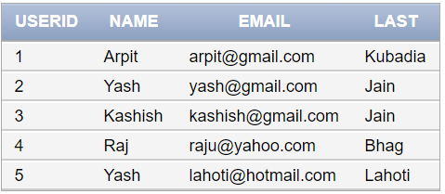

### Pics:

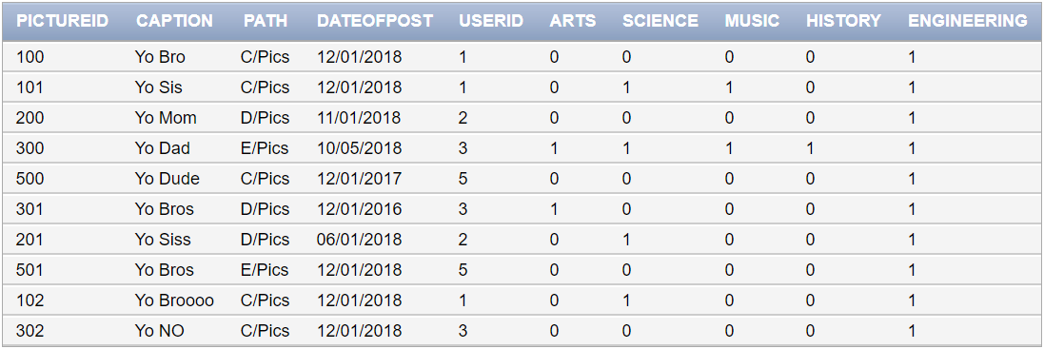

### Likes:

